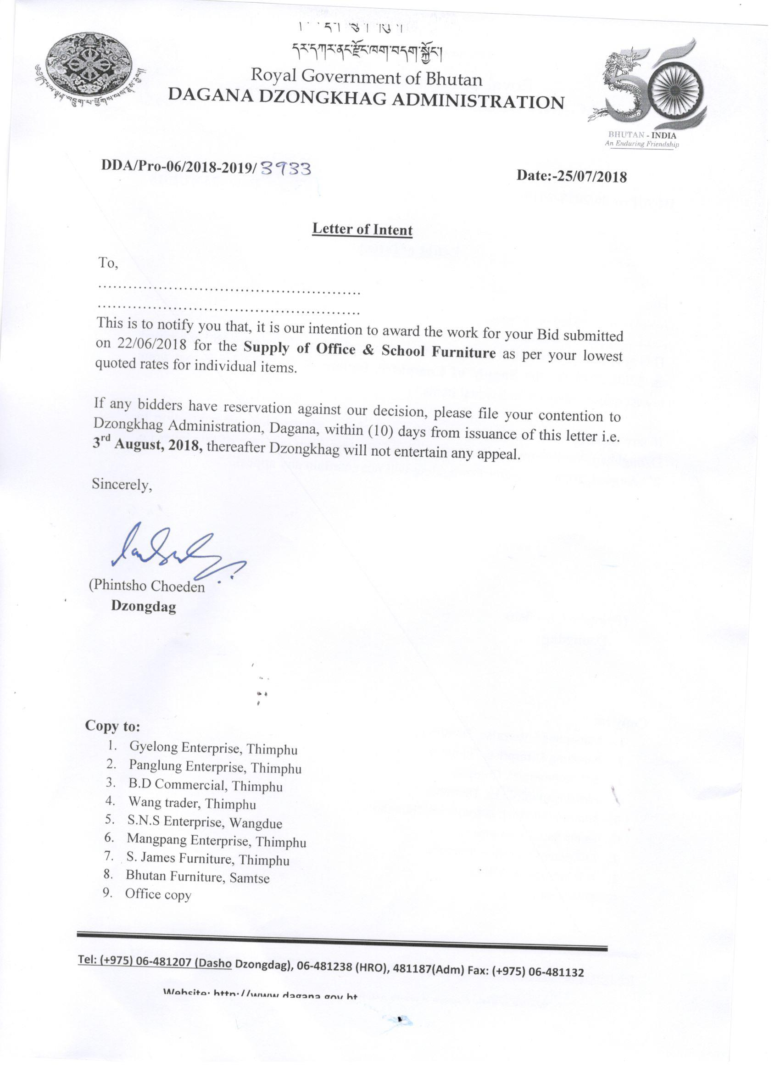
Comparative Statement fro supply of Office & School Furniture 2018-2019
Sl.No. | DESCRIPTION | Unit | Wang Trader Rate | S.N.S Enterprise Rate | B.D. Commercial Rate | Mangpang Enterprise rate | S.James Furniture Rate | Panglung Enterprise Rate | Gyelong Enterprise Rate | Bhutan Furniture rate
1 | Full Secretariat Table | No | 11007 | 7880 | 6190 | 13400 | 9909 | 5705 | 9939 | 7989
2 | Aluminium Partition | sq.ft | 387 | na | na | 320 | 489 | 375 | na | na
3 | Book Shelves with front loading & sliding shutter with 3 shelves size 66"x34"x13" | No | 12275 | na | 14390 | 10900 | 7709 | 8850 | 9939 | 7898
4 | Book Shelves with front loading & sliding shutter with 4 shelves size 72"x36"x13" | No | 13057 | 12000 | 18390 | 12400 | 8209 | 9850 | 10339 | 9889
5 | Chodrum Curved | No | 18401 | 3500 | 6390 | 18500 | 13609 | 13450 | na | 19499
6 | Chodrum plain | No | 5623 | 3300 | 3190 | 12200 | 5609 | 2999 | na | 4989
7 | Computer Chair | No | 4263 | 3950 | 4890 | 4400 | 4609 | 3450 | 4839 | 3489
8 | Computer Table (Art 203) | No | 4897 | 4800 | 3690 | 5339 | 4609 | 4805 | 5139 | 4289
9 | Conference Table with Chair for 30 heads | No | 238525 | 144000 | 148390 | 5500(each) | 9600 | 198000 | 153339 | 235500
10 | Cubcial Box | No | 8251 | na | 19390 | 7700 | 47009 | na | na | 12499
11 | Dewan 5'6"x18"x16" | No | 6075 | 6900 | 5490 | 5100 | 4709 | 4275 | 5639 | 4389
12 | File Rack 54"x48"x12" | No | 7787 | 5930 | 5690 | 6800 | 5709 | 5345 | 5939 | 5489
13 | Guest Chair with cushion & arm | No | 3525 | 3500 | 2890 | 2900 | 2309 | 2290 | 4839 | 1889
14 | Half Secretariat Table | No | 9161 | 4990 | 3490 | 9400 | 6909 | 4535 | 5039 | 5889
15 | Lenolium Carpet (Thick) | sq.ft | 39 | na | 48 | 42 | 29 | 32 | na | na
16 | Lenolium Carpet (Thin) | sq.ft | 33 | na | 24 | 32 | 25 | 28 | na | na
17 | Plastic Chair with arm | No. | 267 | 520 | 439 | 812 | 419 | 375 | 739 | 399
18 | Plastic chair without arm | Each | 575 | 450 | 449 | 640 | 389 | 320 | 639 | 369
19 | Plastic Table | No | 2235 | 2200 | 979 | 3200 | 1709 | 1099 | 2539 | 1989
20 | Revolving Chair (half back) | No | 9439 | 4990 | 4890 | 8400 | 5609 | 5400 | 5539 | 3989
21 | Revolving Chair (high back) | No | 11313 | 6595 | 5490 | 12800 | 8809 | 7600 | 8039 | 5489
22 | Shelf | No | 7501 | na | 9890 | 16400 | 3309 | 5345 | na | 9999
23 | Single Sofa | No. | 10725 | 9600 | 8990 | 17400 | 7309 | 4900 | na | 5489
24 | Sofa Set with best quality cover | Set | 53875 | 37000 | 21890 | 52800 | 28609 | 27900 | 33839 | 22489
25 | Steel Almirah 48"x30"x17" | No | 7133 | 6600 | 8390 | 6100 | 5509 | 7400 | 7123 | 5289
26 | Steel Almirah 50"x30"x17" with locker | No | 8281 | 7800 | 8490 | 6600 | 6109 | 8150 | 7539 | 5489
27 | Steel Almirah 50"x30"x17" without locker | No | 7779 | 7300 | 8490 | 6200 | 6109 | 7250 | 7439 | 5289
28 | Steel Almirah 54"x30"x17" | No | 8393 | 8900 | 9490 | 6800 | 6609 | 8450 | 8039 | 5789
29 | Steel Almirah 60"x30"x17" with locker | No | 9131 | 9990 | 9890 | 7000 | 6909 | 8450 | 8539 | 5889
30 | Steel Almirah 60"x30"x17" without locker | No | 8633 | 9500 | 9890 | 6500 | 6909 | 8150 | 8239 | 5786
31 | Steel Almirah 66"x36"x19" | No | 10135 | 10600 | 11890 | 7400 | 6309 | 8450 | 8839 | 6979
32 | Steel Almirah 72"x36"x19" | No | 10455 | 11600 | 12790 | 9600 | 8309 | 8850 | 10339 | 8379
33 | Steel Bookshelves | No | 12949 | na | 8490 | 8600 | 7809 | 7900 | 10339 | 8789
34 | Steel File Cabinet | No | 15116 | 12000 | 9890 | 9400 | 8409 | 9900 | 11339 | 9889
35 | Steel File Rack (open type) 6'x3' | No | 15027 | 8000 | 9890 | 7000 | 7109 | 4950 | 8839 | 6489
36 | Steel Locker canting 12 chambers for nurses | No | 23069 | na | 18990 | 22800 | 13609 | 14700 | na | 16889
37 | Steel medicine Rack | No | 9051 | na | 9790 | 9000 | 7709 | 7900 | 7039 | 6249
38 | Steel Trunk 28" | No | 2065 | 3200 | 3890 | 1300 | 2609 | 1900 | 8039 | 1899
39 | Steel Trunk 30" | No | 2397 | 3600 | 4390 | 1440 | 2609 | 2100 | 9039 | 2285
40 | Steel Trunk 32" | No | 2731 | 4000 | 4190 | 1600 | 3109 | 2400 | 10039 | 2499
41 | Steel Trunk 34" | No | 3397 | 4400 | 4890 | 1848 | 3309 | 2650 | 11039 | 2999
42 | Steel Trunk 36" | No | 3753 | 4800 | 5490 | 2100 | 3709 | 2750 | 12039 | 3999
43 | Steel Trunk 40"x24"x20" | No | 4297 | 5600 | 5890 | 3700 | 3909 | 2950 | na | 4989
44 | Synthetic Carpet (Plain) | sq.ft | 31 | na | 24 | 24 | 24 | 17 | na | na
45 | Synthetic Carpet (Ribs) | sq.ft | 41 | na | 26 | 34 | 27 | 24 | na | na
46 | Visitor Chair with arm (supreme Ornate) | No. | 4043 | 3400 | 2890 | 3900 | 3109 | 2290 | 3839 | 3489
47 | White Board with stand | No | 11375 | 4500 | 3490 | 7100 | 4309 | 2800 | 8839 | 7489
48 | White Board without stand | No | 8475 | 2800 | 2190 | 4200 | 1909 | 2099 | 8539 | 5489
49 | Wooden Book Shelf 66"x34"x13"  4 shelf with glass & shutter | No | 5755 | 12800 | 28990 | 5380 | 9969 | 9450 | na | 9989
50 | Wooden Cupboard | No | 11205 | 12800 | 18490 | 12400 | 7709 | 7950 | na | 14989
51 | Wooden Cupboard 4 shelf (Standard) | No | 11605 | 13800 | 16490 | 12400 | 8109 | na | na | 16489
52 | Wooden Partition | No | na | na | na | 450 | na | 590 | na | na
53 | Woolen Carpet | sq.ft | 89 | na | 74 | 64 | 62 | 64 | na | na
School Furniture
1 | Square table for Cl. PP | No | 5549 | 3200 | 4890 | 3600 | 4509 | 3750 | na | 3449
2 | Desk B | No | 4249 | 2800 | 3490 | 3300 | 2209 | 2450 | na | 2249
3 | Desk C | No | 4339 | 3200 | 3490 | 3400 | 2209 | 2650 | na | 2289
4 | Desk D | No | 4599 | 3400 | 3490 | 3600 | 2209 | 2850 | na | 2389
5 | Desk E | No | 4847 | 3800 | 3490 | 3800 | 2309 | 2950 | na | 2489
6 | Stool A | No | 395 | 590 | 1749 | 654 | 1109 | 700 | na | 549
7 | Stool B | No | 981 | 620 | 1749 | 540 | 1109 | 750 | na | 599
8 | Stool C | No | 1059 | 680 | 1749 | 580 | 1109 | 790 | na | 649
9 | Stool D | No | 1175 | 790 | 1749 | 870 | 1109 | 800 | na | 699
10 | Chair E | No | 1651 | 3500 | 2390 | 1008 | 1709 | 2450 | na | 1149
11 | Teacher's Table | No | 4531 | 4200 | 6890 | 4040 | 4409 | 3950 | na | 3889
12 | Teacher's Chair with cushion | No | 3333 | 3200 | 4890 | 2900 | 2509 | 2750 | 8039 | 2389
13 | Teacher Chair | No | 2725 | 3000 | 3890 | 2148 | 1909 | 2150 | 7939 | 2289
14 | Notice Board | No | 7725 | na | 2190 | 12000 | 2909 | 2950 | na | 7489
15 | Bench (4 sitter) |  | 2825 | na | 4890 | 2440 | 2409 | 2150 | na | 2389
16 | Bench ( 3seater) | No | 2525 | 3400 | 3690 | 2140 | 2309 | 2099 | na | 1889
17 | Bench (2 seater) | No | 21001 | 2800 | 2890 | 1740 | 1809 | 1790 | na | 1689
18 | Black Board | No | 9063 | 2600 | na | 9000 | 5409 | 8750 | na | 7489
19 | Green Baord | No | 9063 | na | 4790 | 8400 | 4809 | 9450 | na | 6889
20 | Library Counter Table | No | 25699 | na | 18490 | 26100 | 14609 | 14500 | na | 29989
21 | Library Reading Table | No | 5525 | na | 6190 | 8640 | 3309 | 4750 | na | 4489
22 | Wooden Chair | No | 2799 | 3200 | 4890 | 2700 | 1909 | 2750 | na | 1989
23 | Long Bench | No | 21875 | 3400 | 4890 | 2440 | 3609 | 2850 | na | 2489
24 | Wooden open shelf | No | 5901 | 3800 | 9890 | 5100 | 8109 | 5750 | na | 6489
25 | Wooden Library Rack | No | 5901 | na | 11490 | 5100 | 8809 | 9250 | na | 6289
26 | Steel Library Rack | No | 8249 | na | 12190 | 7800 | 8109 | 5450 | na | 6489
27 | Steel open Shelf | No | 7579 | 4200 | 9890 | 7500 | 7709 | 5450 | na | 7289
28 | Steel Lockable Cabinet | No | 9051 | 12000 | 14390 | 9000 | 13609 | 10900 | na | 14989
29 | Wooden lockable cupbaord | No | 12921 | 12000 | 18390 | 13640 | 9609 | 10900 | na | 14889
30 | Periodical rack | No | 15499 | na | 6890 | 26000 | 5609 | 14700 | na | 9989
31 | Periodical stand | No | 11625 | na | 7490 | 12000 | 4909 | 17500 | na | 7489
32 | Card Catalogue | No | 15499 | na | 8490 | 9000 | 5809 | 10400 | na | 9989
33 | Laboratory table | No | 29955 | na | 16490 | 8600 | 9999 | 3900 | na | 14489
34 | Laboratory Stool | No | 5845 | na | 1749 | 800 | 2109 | 900 | na | 1149
35 | Dinning Table | No | 5649 | na | 7690 | 4200 | 4909 | 4999 | na | 4489
36 | Dinning Bench | No | 2749 | 3400 | 3690 | 2600 | 2609 | 1999 | na | 2289
37 | Bunk Bed | No | 10669 | 7800 | 8790 | 8688 | 8809 | 6450 | na | 7989
38 | Plastic stool | No | 547 | 380 | 269 | 640 | 539 | 390 | na | 289
39 | Lab Stool | No | 5841 | 3800 | 1749 | 800 | 1609 | 790 | na | 329
40 | ASTRA SUPER Green Board, Size-(1200x1800mm)  SPBD Code No. BD-06 (ALKOSIGN Brand) | No | 8751 | na | 4790 | 14500 | 4609 | 7900 | na | 7489
41 | ASTRA SUPER Green Board, Size-(1200x2400mm)  SPBD Code No. BD-07 (ALKOSIGN Brand) | No | 10951 | na | 6490 | 18000 | 5609 | 8900 | na | 7549
42 | ASTRA PLUS Wite Graph Board, Size-(1200x1800mm)  SPBD Code No. BD-08 (ALKOSIGN Brand) | No | 8751 | na | 4790 | 14500 | 4609 | 8490 | na | 9489
43 | ASTRA PLUS White Graph Board, Size-(1200x2400mm)  SPBD Code No. BD-09 (ALKOSIGN Brand) | No | 10951 | na | 6490 | 18000 | 5609 | 9900 | na | 9489
44 | ASTRA Cloth Notice Board, Size-(1200x1800mm)  SPBD Code No. BD-10 (ALKOSIGN Brand) | No | 8751 | na | 4790 | 14500 | 4609 | 9900 | na | 7989
45 | Hostel Lockers (St) (SPBD Code No. CB-01) | No | 8759 | na | 14390 | 8700 | 14609 | 5490 | na | 9189
46 | Meat Safe (SPBD Code No. CB-02) | No | 10557 | na | 9890 | 10900 | 7609 | 4790 | na | 6489
47 | Lab. Cupboard (SPBD Code No. CB-06) | No | 11485 | na | 16490 | 10800 | 12609 | 11250 | na | 14889
48 | Locker Box(T) (SPBD Code No. CB-09) | No | 7009 | na | 18490 | 6880 | 9809 | 7950 | na | 14489
49 | Wooden Rack, Type-2 (SPBD Code No. SH-03) | No | 10063 | na | 14390 | 11284 | 7209 | 7900 | na | 6489
50 | Wooden Rack, Type-2 (SPBD Code No. SH-04) | No | 10063 | na | 16490 | 11284 | 8709 | 7900 | na | 7489
51 | Store Steel Rack (SPBD Code No. SH-05) | No | 7737 | na | 9890 | 7688 | 9709 | 7950 | na | 7489

