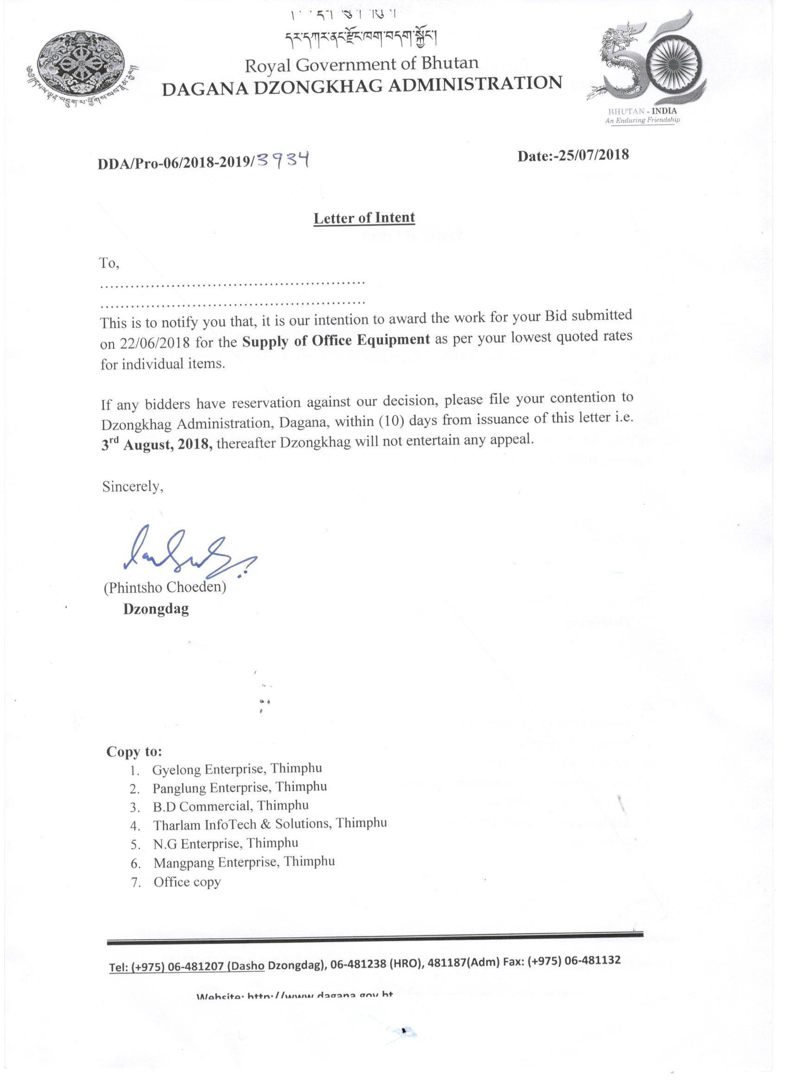
Comparative Statement for supply of Office Equipment for 2018-2019
Sl. No. | Particulars | Specification | Unit | N. G Enterprise Rate | B.D Commercial Rate | Mangpang Enterprise Rate | Tharlam Infotech & Solution Rate | Panglung Enterprise rate | Gyelong Enterprise Rate
1 | PHOTOCOPY MACHINE
a | Photocopy machine, with latest technology (with Latest detail specifications) |  | Each | 48000 | 41490 | 39600 | 38650 | 49000 | 42,500 (konica-185e)
b | Heavy duty photocopy machine Duplex , with latest technology (with latest detail specifications) |  | Each | 119000 | 89490 | 63800 | 58650 | 89000 | 76,500 (konica-206)
c | Photocopy Machine Canon IR2016 |  | Each | 49000 | 74390 | 107800 | 108950 | 67000 | Na
d | Projector sony ( Infocus with white screen 2000luminius epson luminius acer 3000 luminius) |  | Each | 51000 | 8990 | 33600 | 32850 | 31000 | 29,000
2 | PRINTERS
a | HP LaserJet Printer 1018/1108 |  | Each | 10500 | 8990 | 6450 | 9850 | 9800 | 10828
b | HP Laser Jet Printer P1102/1108 |  | Each | 10600 | 8990 | 7300 | 9850 | 9900 | 10828
c | HP Laser Jet Printer P1007/1108 |  | Each | 10700 | 8990 | 7300 | 9850 | 8400 | 10828
d | HP Laser Jet Printer P 2055/402 |  | Each | 21000 | 16490 | 17200 | 18150 | 16900 | 22000
e | HP LaserJet Printer (Duplex) 2055D/402d |  | Each | 26000 | 16490 | 17200 | 19150 | 17900 | 21000
f | HP Laser Jet Printer 2055DN heavy duty/402 dn |  | Each | 31000 | 18490 | 17200 | 19750 | 19200 | 23000
g | HP Laser Jet Printer 3015DN Heavy Duty |  | Each | 35000 | 36490 | 30100 | 36650 | 34900 | 30185
h | HP Laser Jet Printer (all in one/ multi functional) |  | Each | 21000 | 14490 | 21800 | 21850 | 14900 | 22500
i | HPLaser Jet Printer Pro 400M40LD |  | Each | 23000 | 16490 | 17200 | 17500 | 17900 | 21000
j | Digital Printer RISO |  | Each | na | 145000 | 153200 | 120000 | 129000 | 150000
k | Printer Canon LBP 3300 |  | Each | 51000 | 18490 | 11650 | 17350 | na | Na
l | Dotmatric Printer LQ2180 Epson |  | Each | 49000 | 48390 | 33650 | 41850 | 41000 | 44500
3 | External Drives
a | 500GB |  |  | 5800 | 4290 | 3640 | 3750 | 3900 | 5000
b | 1000 GB |  | No. | 5800 | 5190 | 4640 | 4250 | 4100 | 6000
4 | USB DRIVES
a | 4 GB |  | No. | 3800 | 439 | 350 | 355 | na | Na
b | 8 GB |  | No. | 4900 | 439 | 410 | 375 | 398 | Na
c | 16 GB |  |  | 6800 | 439 | 560 | 585 | 435 | Na
5 | Camera
a | Canon | 700D(18-55mm) | No. | 63000 | 38980 | 8100 | 8250 | 54000 | 34000
b | Sony |  | No. | 63000 | 84390 | 8800 | 8460 | 38000 | Na
6 | TELEPHONE HEADS
a | Telephone with speaker |  | Each | 2100 | 2490 | 2200 | 2150 | 1600 | 4800
b | Telephone head |  | Each | 3500 | 879 | 1540 | 1550 | 749 | 1500
7 | Scanner machine
 | Scanner | cannon lid 120 | Each | 5600 | 5490 | 5400 | 4850 | 5600 | 5980
8 | Switch and Router
a | 8 Port gigabit Dlink switch |  | Each | 3100 | 2849 | 2040 | 2650 | 2400 | Na
b | 16 port gigabit Dlink switch |  | Each | 8000 | 6849 | 5500 | 4450 | 5800 | Na
c | 24 port gigabit Dlink switch |  | Each | 13000 | 8990 | 6800 | 6550 | 7800 | Na
d | Cisco 1841 Router |  |  | na | 68490 | 52600 | 51850 | 45000 | 155800
9 | Duplicating Machine
a | Ink for RISO |  |  | na | 1249 | 1400 | 1250 | 1290 | na
b | Master for RISO |  |  | na | 1249 | 1780 | 1750 | 1290 | Na
c | Ink for Rongda |  |  | na | 989 | 1310 | 1350 | 950 | Na
d | Master for Rongda |  |  | na | 2490 | 1988 | 1950 | 2100 | Na
e | Duplicating Machine RONGDA | RD3608,300-400 DPI | Each | na | 118490 | 107000 | 115000 | 129000 | Na
f | Cyclostyle machine parts |  |  | 14000 | 16490 | 78000 | 1950 | 10000 | Na

