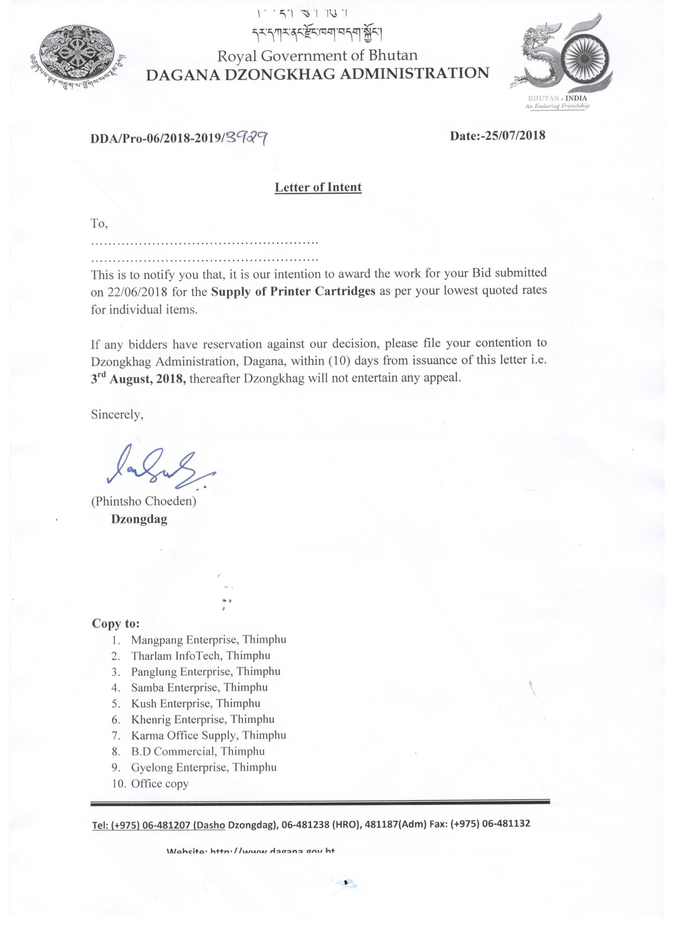
Printer Cartridges (Original)
Sl.No. | Description | Specification | Unit | Mangpang Enterprise Rate | Tharlam Infotech & Solution Rate | Panglung Enterprise rate | Samba Enterprise Rate | Kush Enterprise Rate | Khenrig Enterprise Rate | Karma Office Supply Rate | B.D Commercial Rate | Gyelyong Enterprise Rate | N.G Enterprise Rate
1 | Printer cartridge | LBP 2900(canon) | Each | 3688 | NA | 9800 | 8200 | na | NA | 1500 | 4890 | na | 2900
2 | Photo copy Toner Bizhub 215 | TN 114, 116 & 115 | Each | 1688 |  | 1800 | 2260 | 1280 |  | 1500 | 1849 | 2880 | 1800
3 | Photocopy toner | Cannon IR-2016, IR2116 NPG-28 | Each | 2800 |  | 2800 | 4300 | na |  | 1500 | 1949 | 3980 | 2500
4 | Photocopy toner | NPG -20(Cannon-IR-1600) | Each | 3084 |  | 2800 | na | 2600 |  | 1500 | 1949 | na | 2800
5 | Photocopy toner | canon iR2318L | Each | 3084 |  | 3900 | 5620 | na |  | 1500 | 1849 | na | 2650
6 | Photocopy toner | Sharp AR-5516 | Each | 5188 |  | 9400 | 7620 | na |  | 3500 | 4690 | 7490 | 5600
7 | Printer cartidge | [SHP 50626A] | Each | 6800 |  | 10800 | 7620 | na |  | na | na | na | 5600
8 | Printer cartidges | 3050(12A) | Each | 2688 |  | 2800 | 3260 | 3400 |  | 1500 | 3490 | 2480 | 2700
9 | Printer cartridge | Q 2610A | Each | 5888 |  | 6000 | 6260 | 5400 |  | 4500 | 6890 | 6490 | 6900
10 | Printer cartridge | Q 2613 A | Each | 4888 |  | 4000 | 2600 | 3400 |  | 1500 | 4890 | 2990 | 5300
11 | Printer cartridge | 36 A | Each | 2688 |  | 3200 | 2960 | 3400 |  | 1500 | 2890 | 2890 | 2690
12 | Printer cartridge | 55A | Each | 7688 |  | 6000 | 6260 | 5400 |  | 4000 | 5890 | 5480 | 5800
13 | Printer cartridge | P2055D or 05 A | Each | 4088 |  | 4000 | 3160 | 5400 |  | 1800 | 3990 | 3480 | 3900
14 | Printer cartridge | (Q7553A) LP Laserjet | Each | 5088 |  | 4000 | 2960 | 3400 |  | 1800 | 3690 | 3990 | 4300
15 | Printer cartridge | 15A HP LaserJet | Each | 4488 |  | 4000 | 3260 | na |  | 1500 | 3190 | 3290 | 5300
16 | Printer cartridage | FX 9A | Each | 3188 |  | 2800 | 4620 | 2900 |  | 1500 | 4390 | 4290 | 2950
17 | Printer cartridge | CE 285A (85A) | Each | 2888 |  | 2800 | 2460 | 2700 |  | 1500 | 3190 | 2890 | 2850
18 | Printer cartridge | HP 53A | Each | 4888 |  | 3000 | 2960 | 3400 |  | 1800 | 3690 | 3990 | 4900
19 | Printer cartridge | HP laser-jet CB/435A | Each | 3188 |  | 2800 | 6860 | 3200 |  | 1500 | 2890 | 2490 | 2650
20 | Printer cartridge | ink Deskje-720 | Each | 2900 |  | na | 1460 | 1600 |  | 3500 | 2990 | na | 2900
21 | Printer cartridge | laser jet 1200 [C7115A] | Each | 4488 |  | 4000 | 3260 | 3400 |  | 1500 | 3190 | 3990 | 4900
22 | Printer cartridge | LBP 3300 cannon 308 | Each | 2088 |  | 3200 | 4620 | 4200 |  | 1500 | 4390 | 6490 | 2830
23 | Printer cartridge | Q 5949A | Each | 4788 |  | 4000 | 3221 | 4200 |  | 1800 | 3790 | 3990 | 3940
24 | Printer cartridge | Q2612A HP Laser Jet 12A | Each | 2688 |  | 2800 | 2460 | 3400 |  | 1500 | 3490 | 2480 | 2700
25 | Printer catridge | HP Laser jet P2015 | Each | 5088 |  | 4000 | 2860 | 3400 |  | 1800 | 3690 | 3990 | 4300
26 | printer Cartridge | AR5516 | Each | 6088 |  | 9600 | 7620 | 5400 |  | 3500 | 4690 | 7490 | 5600
27 | printer cartridge | HP (P1007)(CC388A) | Each | 2688 |  | 2800 | 2460 | 2800 |  | 1500 | 2490 | 2890 | 2650
28 | Printer cartridge | hp laserjet 2420 | Each | 6588 |  | 6000 | 9820 | na |  | 4000 | 6490 | 5290 | 5600
29 | Printer cartridge | 88A | Each | 2688 |  | 2800 | 2360 | 2800 |  | 1500 | 2490 | 2890 | 2650
30 | Riso | KS - 800 Ink | Each | 2188 |  | 1600 | 2460 | 2700 |  | 1500 | 1890 | 3800 | na
31 | Ink for Rongda | Original with Rongda print R-303N/R- 323 | Each | 1688 | 1250 | 1100 | 2960 | 1780 |  | 1500 | 1149 | na | na
32 | Master for Rongda | Original with Rongda print | Each | 1688 | 1350 | 2100 | 2960 | 2700 |  | 2200 | 2690 | na | na
33 | Riso | KS -800 master | Each | 2688 | 1950 | 1600 | 2460 | 2700 |  | 1800 | 1849 | 3900 | na
34 | Printer cartridge | 51 A | Each | 6888 | 1750 | 6000 | 6260 | 5300 |  | 4000 | 6490 | 5280 | 7300
35 | Printer cartridge | 303 | Each | 2888 | NA | 2800 | 6260 | 3300 |  | 1500 | 4390 | 4480 | 2950
36 | print Cartridge | Hp 35A Laserjet | Each | 2688 |  | 2200 | 3160 | 3300 |  | 1500 | 3190 | 2490 | 2700
37 | Printer Cartridge | Hp 1020 (dungyi) | Each | 2788 |  | 2200 | 2620 | 2800 |  | 1500 | 3490 | na | 2750
38 | Cartridge digital printer | 3608 | Each | 2888 |  | 975 | 7620 | na |  | 1500 | 1149 | na | na
39 | Canon Print Cartridge | 328 Starter | Each | 2685 |  | 2200 | 2460 | na |  | 1500 | 4390 | 4980 | 2850
40 | Printer cartridge | TN118 | Each | 1688 |  | 1800 | 2160 | 1450 |  | 1500 | 1890 | 2880 | 2100
41 | Printer cartridge | HP Laser Jet Pro M402dn | Each | 6888 |  | 4100 | 6260 | 6400 |  | 3000 | 5490 | 3990 | 5300
42 | Printer cartridge | 26A(CF226A) | Each | 6888 |  | 3200 | 6260 | 6400 |  | 3000 | 5490 | 3980 | 5300
43 | Printer cartridge | HP Laser Jet P1102W | Each | 2888 |  | 2200 | 7620 | 3100 |  | 1500 | 3690 | 4290 | 2650
44 | Ribon set for EPSON printer | LQ-1150 | Pkts | 748 |  | 675 | 1360 | 560 |  | 600 | 949 | na | na
45 | Ribon set for EPSON printer | LQ-2180 | Pkts | 948 |  | 675 | 1365 | 2600 |  | 1200 | 1149 | na | na
 | Printer Cartridges (Refurbished)
Sl/No. | Description | Specification | Unit | Mangpang Enterprise Rate (Nu.) | Tharlam Infotech & Solutions Rate | Panglung Enterprise Rate | Samba Enterprise Rate | Kush Enterprise Rate | Khenrig Enterprise Rate | Karma Office Supply Rate | B.D Commercial Rate | Gyelyong Enterprise Rate | N.G Enterprise Rate
1 | Printer cartridge | LBP 2900(canon) | Each | 1780 | 1025 | 4000 | 3620 | 1880 | 1350 | 1000 | 1390 | na | 1300
2 | Photo copy Toner Bizhub 215 | TN 114, 116 & 115 | Each | 1600 | 1650/950/1550 | 1100 | 1460 | 1280 | 999 | 1000 | 1280 | 1880 | 1650
3 | Photocopy toner | Cannon IR-2016, IR2116 NPG-28 | Each | 1280 | 1200 | 1200 | 3200 | 1880 | 900 | 1500 | 1890 | 2490 | 1750
4 | Photocopy toner | NPG -20(Cannon-IR-1600) | Each | 1468 | 1350 | 1200 | 3200 | 2600 | 2300 | 1500 | 1890 | na | 1750
5 | Photocopy toner | canon iR2318L | Each | 1800 | 1350 | 1800 | 4620 | 1280 | na | 1500 | 1890 | na | 2350
6 | Photocopy toner | Sharp AR-5516 | Each | 6800 | 2450 | 6000 | 4620 | 3982 | 2400 | 2500 | 2690 | 5680 | 4100
7 | Printer cartidge | [SHP 50626A] | Each | 6848 | 2450 | 6000 | 4620 | na | 3600 | na | na | na | 4100
8 | Printer cartidges | 3050(12A) | Each | 848 | 620 | 900 | 1160 | 1380 | 749 | 1000 | 894 | 1290 | 800
9 | Printer cartridge | Q 2610A | Each | 1680 | 1350 | 2400 | 3260 | 4220 | 2800 | 3000 | 1649 | 4290 | 3100
10 | Printer cartridge | Q 2613 A | Each | 1400 | 1250 | 1800 | 1500 | 2450 | 1200 | 1100 | 1149 | 1890 | 1380
11 | Printer cartridge | 36 A | Each | 848 | 650 | 900 | 1260 | 1480 | 779 | 1100 | 798 | 1690 | 810
12 | Printer cartridge | 55A | Each | 2448 | 1450 | 2400 | 3260 | 3280 | 2400 | 2200 | 1890 | 3890 | 2400
13 | Printer cartridge | P2055D or 05 A | Each | 1048 | 750 | 1000 | 1150 | 1480 | 849 | 1100 | 879 | 1890 | 1000
14 | Printer cartridge | (Q7553A) LP Laserjet | Each | 1048 | 680 | 1000 | 1150 | 1480 | 849 | 1200 | 949 | 1980 | 1450
15 | Printer cartridge | 15A HP LaserJet | Each | 848 | 950 | 1000 | 1150 | 2400 | 1050 | 1100 | 979 | 1980 | 1500
16 | Printer cartridage | FX 9A | Each | 1010 | 950 | 1200 | 2960 | 1880 | 849 | 1100 | 1349 | 2490 | 1150
17 | Printer cartridge | CE 285A (85A) | Each | 848 | 750 | 900 | 1160 | 1680 | 749 | 1000 | 1249 | 1890 | 900
18 | Printer cartridge | HP 53A | Each | 1048 | 720 | 1000 | 1150 | 2380 | 849 | 1200 | 949 | 1990 | 1500
19 | Printer cartridge | HP laser-jet CB/435A | Each | 848 | 750 | 900 | 1150 | 1880 | 950 | 1100 | 879 | 1590 | 810
20 | Printer cartridge | ink Deskje-720 | Each | 3800 | na | na | 1420 | 1380 | na | 3500 | 2990 | na | 2800
21 | Printer cartridge | laser jet 1200 [C7115A] | Each | 1448 | 950 | 1000 | 1260 | 2600 | 1050 | 1100 | 979 | 1880 | 1550
22 | Printer cartridge | LBP 3300 cannon 308 | Each | 1444 | 1200 | 1200 | 2960 | 2600 | 1050 | 1100 | 1349 | 2490 | 1200
23 | Printer cartridge | Q 5949A | Each | 1148 | 750 | 1000 | 1160 | 1950 | 849 | 1200 | 969 | 1980 | 1550
24 | Printer cartridge | Q2612A HP Laser Jet 12A | Each | 848 | 620 | 900 | 1202 | 1380 | 749 | 1000 | 879 | 1290 | 815
25 | Printer catridge | HP Laser jet P2015 | Each | 1148 | 750 | 1000 | 1100 | 1780 | 1050 | 1200 | 1349 | 1980 | 1550
26 | printer Cartridge | AR5516 | Each | 3400 | 2850 | 6000 | 3860 | 3700 | 2400 | 2500 | 2649 | 4980 | 4500
27 | printer cartridge | HP (P1007)(CC388A) | Each | 848 | 575 | 875 | 1010 | 1380 | 715 | 1000 | 739 | 1480 | 799
28 | Printer cartridge | hp laserjet 2420 | Each | 1800 | 1650 | 2400 | 4260 | na | 3300 | 2500 | 1849 | 3990 | 2500
29 | Printer cartridge | 88A | Each | 848 | 575 | 875 | 1010 | 1380 | 739 | 1000 | 739 | 1480 | 799
30 | Riso | KS - 800 Ink | Each | 1448 | 1250 | 1290 | 2160 | 1780 | na | 1500 | 998 | 1990 | na
31 | Ink for Rongda | Original with Rongda print R-303N/R- 323 | Each | 1688 | 1350 | 870 | 3100 | 1780 | na | 1500 | 839 | na | na
32 | Master for Rongda | Original with Rongda print | Each | 2448 | 1950 | 1800 | 2960 | 2700 | na | 2200 | 1649 | na | na
33 | Riso | KS -800 master | Each | 1448 | 1750 | 1200 | 3000 | 2700 | na | 1800 | 998 | 2500 | na
34 | Printer cartridge | 51 A | Each | 1688 | 1350 | 2400 | 3360 | 2780 | 2800 | 2500 | 2190 | 3990 | 2250
35 | Printer cartridge | 303 | Each | 1044 | 1050 | 1200 | 3360 | 1980 | 1250 | 1000 | 1249 | 2480 | 1120
36 | print Cartridge | Hp 35A Laserjet | Each | 1044 | 750 | 900 | 1160 | 1980 | 950 | 1100 | 839 | 1590 | 815
37 | Printer Cartridge | Hp 1020 (dungyi) | Each | 848 | 740 | 900 | 1020 | 1380 | 950 | 1000 | 879 | na | 799
38 | Cartridge digital printer | 3608 | Each | 1800 | 405 | 800 | 3600 | na | 1700 | 1500 | 839 | na | na
39 | Canon Print Cartridge | 328 Starter | Each | 888 | 950 | 1200 | 1400 | 1980 | 1050 | 1000 | 1349 | 2990 | 1020
40 | Printer cartridge | TN118 | Each | 1448 | 950 | 1100 | 1400 | 1450 | 999 | 1000 | 1280 | 2180 | 1650
41 | Printer cartridge | HP Laser Jet Pro M402dn | Each | 5484 | 3550 | 1200 | 3900 | 2640 | 3800 | 2500 | 3190 | 2180 | 3900
42 | Printer cartridge | 26A(CF226A) | Each | 6800 | 3550 | 2000 | 3200 | 2640 | 3800 | 2500 | 3190 | 2180 | 3900
43 | Printer cartridge | HP Laser Jet P1102W | Each | 884 | 750 | 900 | 7600 | 1780 | 749 | 1000 | 1390 | 2180 | 900
44 | Ribon set for EPSON printer | LQ-1150 | Pkts | 448 | 210 | 600 | 1000 | 560 | na | 600 | 949 | na | na
45 | Ribon set for EPSON printer | LQ-2180 | Pkts | 448 | 450 | 600 | 1000 | 2600 | na | 1200 | 1149 | na | na

