TABLE OF CONTENTS

BACKGROUND 1

LOCATION & AREA 3

FACTS OF DAGANA DZONGKHAG 4

POPULATION AND LAND USE (2018) 4

RNR INSTITUTIONS AND STATUS 4

IRRIGATION SCHEMES (Functional) 4

HEALTH 4

EDUCATION 5

LOCAL GOVERNMENTS 5

ELECTRICITY 5

WATER AND SANITATION 6

COMMUNICATIONS 6

ROAD NETWORK (KM) 6

RELIGION & CULTURE 6

TRANSPORTATION 6

# BACKGROUND

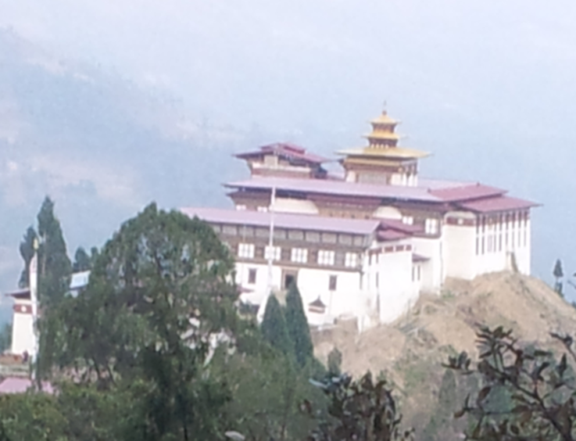Dagana Dzongkhag has one Dungkhag and 14 Gewogs under its administration. The Dungkhag is Lhamoi Dzingkhag and the Gewogs are Dorona, Drukjegang, Gesarling, Gozhi, Karmaling, Karna, Khebisa, Largyab, Lhamoi Dzingkha, Nichula, Tashiding, Tsangkha, Tsendagang and Tseza. Dagana Dzongkhag comprises Dzongkhag Tshogdue (DT) and of It has 29 Gewog Tshogde (GT), while DT is the highest decision making body in the Dzongkhag, GT has same authority at the Gewog level. There are 29 DT members while GT has 7 members with a total of 98 members.

The name ‘Dagana’ is derived from the words – Darkala and Darkarnang. The former refers to the province’s guardian deity – Jomo Darkamo and the latter means ‘The Realm of White Prayer Flags’.

Zhabdrung Ngawang Namgyal managed to unify most of western Bhutan by mid-17th century but the central, eastern and southern parts still remained so he deputed his Dronyer Druk Namgyelto Darkala in 1648 to bring the area under the central rule and also commanded him to build a Dzong to defend the country from the invading armies from south. Two years later in 1651, the Dzong was completed and was formally named by Zhabdrung as Daga Trashiyangtse Dzong. Tenpa Thinley was appointed as the first Daga Poenlop. The office of the Daga Penlop held the rank of cabinet minister under the Desi (temporal ruler) system of government introduced by the Zhabdrung.

Following is the list of officials who served as Penlops, Dzongpons, Dzongtshabs, Nyerchens, Thrimtshabs and Dzongdags in Dagana Dzongkhag:

1. Tempa Thinley Penlop 1651

2. Tshelthrium Jungnay Penlop not available

3. Rigzin Lhundrup Penlop not available

4. Rabten Penlop not available

5. Tenzin Wangpo Penlop not available

6. Padkar Jungney Penlop not available

7. Tshering Dendup Penlop not available

8. Dorji Norbu Penlop not available

9. Tashi Gangpa Penlop not available

10. Tshewang Phuntsho Penlop not available

11. Samten Dorji Penlop not available

12. Jamo Serpo Penlop not available

13. Doyon Chelwa Penlop not available

14. Tsithub Penlop not available

15. Tsewang Dorji Penlop not available

16. Phowa Bom Nyerchen not available

17. Martogpa Nyerchen not available

18. Chungkhab Rinzin Dzongpon not available

19. Gasing Dungpa Dzongtshab not available

20. Rigzin Dorji Dzongpon not available

21. Haap Doley Dzongpon 1954-1959

22. Tandin Dorji Thrimtshab 1959-1964

1. Kawang Rinchen Dzongdag 1964-1967
2. Jangwang Darpo Dzongdag 1967-1974
3. Sha Chethey Dzongdag 1974-1978
4. Sha Namgyel Dzongdag 1978-1980
5. Karma Sherpa Dzongdag 1980-1983
6. Thinley Yoezer Dzongdag 1983-1986
7. Tsheltrim Gyaltshen Dzongdag 1986-1987
8. Gaseb Lhundup Dzongdag 1987-1988
9. Karma Dorji Dzongdag 1988-1990
10. Hari Sonam Tobgay Dzongdag 1990-1991
11. Yeshi Tshering Dzongdag 1991-1998
12. Mingbo Dukpa Dzongdag 1998-2003
13. Sangay Dorji Dzongdag 2003-2003
14. Goling Tshering Dzongdag 2003-2007
15. Tashi Gyeltshen Dzongdag 2007-2011
16. Tenzin Thinley Dzongdag 2012-2016
17. Phintsho Choeden Dzongdag 2016-

# LOCATION & AREA

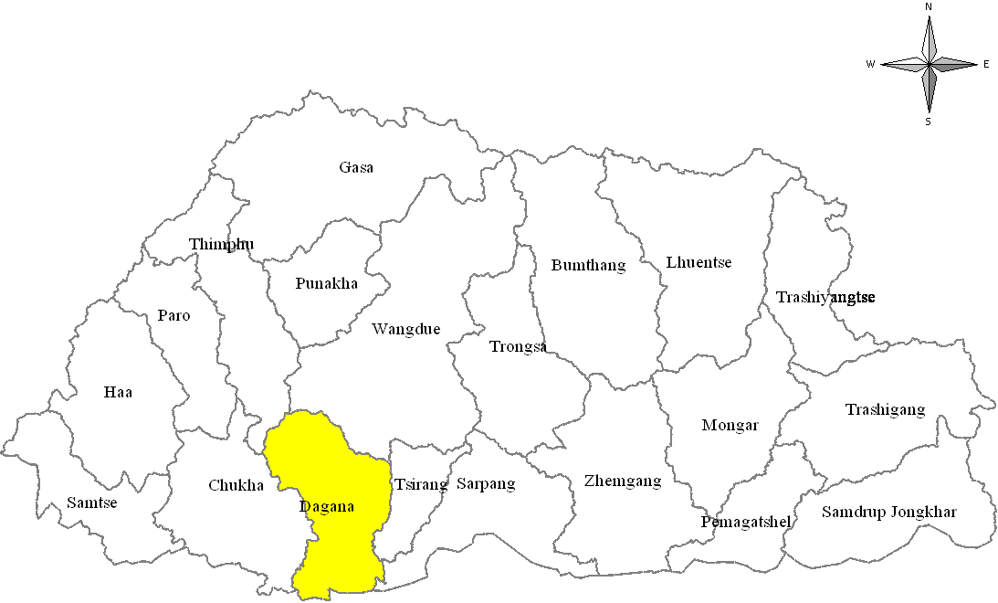The Dzongkhag shares its border with Thimphu and Chukha Dzongkhag in the west, Wangduephodrang Dzongkhag to the north, Tsirang Dzongkhag to the east and India to the south. Dagana is 230 km away from Thimphu, the capital city and is lies in Central part of the Kingdom with total area about 1722.6 square kilometers.The Dzongkhag falls within the temperate zone in the north and the sub-tropical zone in the south. Summers are hot and wet and winters dry and cold with elevation ranging from 180 to 3800 meters above sea level. The lowest human settlement is found in southern foothills of Lhamoi Dzingkha.



Dagana falls under Tseza gewog and is where the Dzongkhag Administration Headquarter is located.

# FACTS OF DAGANA DZONGKHAG

# POPULATION AND LAND USE (2018)

Population 29216

Male 14821

Female 14395

Households 5239

Urban 543

Rural 4696

Gungtong households 275

Population density (persons per sq. km) 17

Population sex ratio (per 100 female) 103

Total Area (sq.km) 1,722.57

Forest Cover (%) 87.05

Total Agricultural land (acres) 18621.86 (7536 Ha)

Total wetland cultivated (acres) 3787.5

Total dry land cultivated (acres) 11915

Poverty Rate (BLSS 2017) 33.3

Unemployment Rate (BLSS 2017) 0.6

Labour Force Participation Rate (BLSS 2017) 69.2

# RNR INSTITUTIONS AND STATUS

RNR Centre 14

Veterinary Hospital 1

Wild Life Sanctuary 1

Registered Agriculture Groups (no) 5

Registered Livestock Groups (no) 12

Household with improved Poultry shed 97

Household with improved Dairy shed 397

Household with improved Piggery shed 180

Household connected with Biogas plant 194

Electric Fencing (km) 158.69

Power Tillers (Government supply) 30

# IRRIGATION SCHEMES (Functional)

Total Number of Irrigation Schemes (no.) 231

Total Lengths of irrigation Schemes (km) 526.35

# HEALTH

Life Expectancy (years) 65.1

Crude Birth Rate 15.5

General Fertility Rate 19.9

General Marital Fertility Rate 26.3

Total Fertility Rate 0.7

Infant Mortality Rate (per 000 Live births) 13.7

Hospital 1

Basic Health Units 9

BHU Grade I 2

BHU Grade II 7

Indigenous units 3

Outreach Clinics 33

Doctors 6

RWSS Coverage (%) 99

Sanitation Coverage (%) 97.7

# EDUCATION

Extended Classrooms 3

Primary Schools 12

Lower Secondary Schools 3

Middle Secondary Schools 2

Central Schools 4

Early Child Care Development (ECCD) Centers 21

Facilitators 26

Learners 428

Boys 219

Girls 209

Non-Formal Education centers 41

Instructors 43

Learners 512

Male …

Female …

Students 6572

Boys 3331

Girls 3240

Teachers 370

Student Teacher Ratio (students per teacher) 17.8

Net Enrolment Rate (%) 99.9

# LOCAL GOVERNMENTS

Gewogs 14

Chiwogs 70

DT members 29

Male 27

Female 2

GT members 98

Male 91

Female 7

# ELECTRICITY

Electricity Coverage 99.11

Electricity Consumption (mega watt per hour) 2.205

Consumers 5252

Off Grid Households 32

# WATER AND SANITATION

RWSS Coverage (%) 94.5

Sanitation Coverage (%) 97.7

# COMMUNICATIONS

Community Centers 14

Gewogs accessible to Mobile services 14

Post Offices 4

Number of Bridges/Suspension Bridges 19

# ROAD NETWORK (KM)

Dzongkhag Sub National Highway 128

Gewog Connectivity Roads 116

Forest Roads 18.5

Farm Roads 570.1 (157 schemes)

# RELIGION & CULTURE

Lhakhangs 53

Government 25

Community 21

Private 7

Chortens 128

# TRANSPORTATION

Bus 10

Taxi (registered) 21

Heavy (registered) 4

Medium (registered) 1

Small (registered) 37

Two wheelers (registered) 4

Auto Mobile Workshops 8

Bus stations 4